Medxcel EDL and Analytics  
QA Deployment instructions v4.0

Version 4.0 | April 26, 2018

# **Deployment of objects in QA:**

## Copying workflow files into HDFS, HIVE table creation and loading data into DLZ, DSZ:

* 1. **Preparation:** 
     1. All the files required for the workflows are available in the folder deploy.

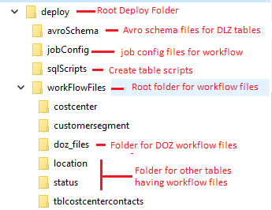

* + 1. AIS to provide HDFS location for deploying workflow, HQLscripts etc.. related files corresponding to QA and Prod (ROOT_FOLDER_IN_HDFS_FOR_DEPLOYMENT_FILES)
    2. AIS to copy below script “*workflowDeployment.sh*” and “deploy” folder in same folder on edge node 704 (*ahlclotxpla704.evv1.ah-isd.net*)
    3. Provide execute permission on *workflowDeployment.sh*
    4. Copy jobConfig on an edge server.
  1. **Execution:** 
     1. Execute in shell the following “*workflowDeployment.sh*” deployment script as per below commands



*./workflowDeployment.sh <ROOT_FOLDER_IN_HDFS_FOR_DEPLOYMENT_FILES>*

* + 1. A property file *job.properties* will be provided to trigger the bundle/workflows in folder deploy/jobConfig.

# 

# Additional information on scripts:

## Deploy scripts logic:

1. Create following directories in HDFS.
   1. *hdfs://nameservice-dev/user/oozie/share/lib-ext/medxcel/scripts/hqlScripts*
   2. *hdfs://nameservice-dev/user/oozie/share/lib-ext/medxcel/scripts/coordinator*
   3. *hdfs://nameservice-dev/user/oozie/share/lib-ext/medxcel/scripts/workflow*
   4. *hdfs://nameservice-dev/user/oozie/share/lib-ext/medxcel/scripts/bundle*
   5. *hdfs://nameservice-dev/user/oozie/share/lib-ext/medxcel/scripts/avroSchema*

*In case there is a change in directory location we need to regenerate all the workflow files accordingly.*

1. Copy all the workflow related files in relevant directories. Like all Hive query scripts in *sqlScripts* folder, similarly for other type of files.
2. Create Hive tables.

## Rollback scripts logic:

1. Remove folder *jobConfig* on an edge server.
2. Keep *rollbackFilesAndTableDrop.sh* and *rollback* folder in same folder.
3. Provide execute permission to *rollbackFilesAndTableDrop.sh*
4. Run *rollbackFilesAndTableDrop.sh <ROOT_FOLDER_IN_HDFS_FOR_DEPLOYMENT_FILES>*





Deploy folder contents



Rollback folder contents

